1.

// a crazy mixed up program  
public class Columbus  
{  
 public static void main(String[] args)  
 {  
 System.out.println("In 1492 Columbus sailed the ocean blue.");  
 }  
}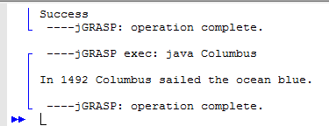  
  
2.Columbus

3.public class Hello

{

public static void main(String [] args)

{

System.out.println(“Hello”);

}

}

4. //9/20/2012

public class Name

{

public static void main (String[] args)

{

System.out.print(“Colin Fausnaught\n”);

}

}

5. c. .java

6. a. a method named main

7. // it's a mad mad program.  
public class Success  
{  
public static void main(String[] args)  
{  
System.out.print("Success\n");  
System.out.print("Success ");  
System.out.print("Success\n");  
System.out.print("\nSuccess");  
}

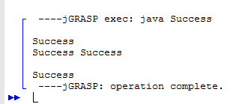

8.

The works of Wolfgang

Include the following

The Turkish March and Symphony No. 40 in G minor

9.

//9/20/2012

public class Name

{

public static void main (String[] args)

{

System.out.print(“Colin Fausnaught\n”);

System.out.print(“1885 Ravine rd\n”);

System.out.print(“Williamsport PA, 17701\n”);

System.out.print(“5703265181\n”);

}

}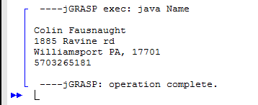

18.

a. char letter;

b. letter = ‘A’;

c. system.out.println(letter)

22.

21

2

31

5

24

2

69

23.

Integer division, 23.0.

27.

String city = “San Francisco”;

28.

length = city.length();

29.

oneChar = city.charAt(1);

30.

upperCity = city.toUpperCase();

31. lowercity = city.toLowerCase();